**Name: Heet Patel**

**Roll number: 24BPEO74**

**Branch: Petroleum**

**Semester: 2nd**

**Division: 2**

**Batch: P3**

**Lab: 3**

1. Count how many vowels are there in a string. Accept the string from the user.

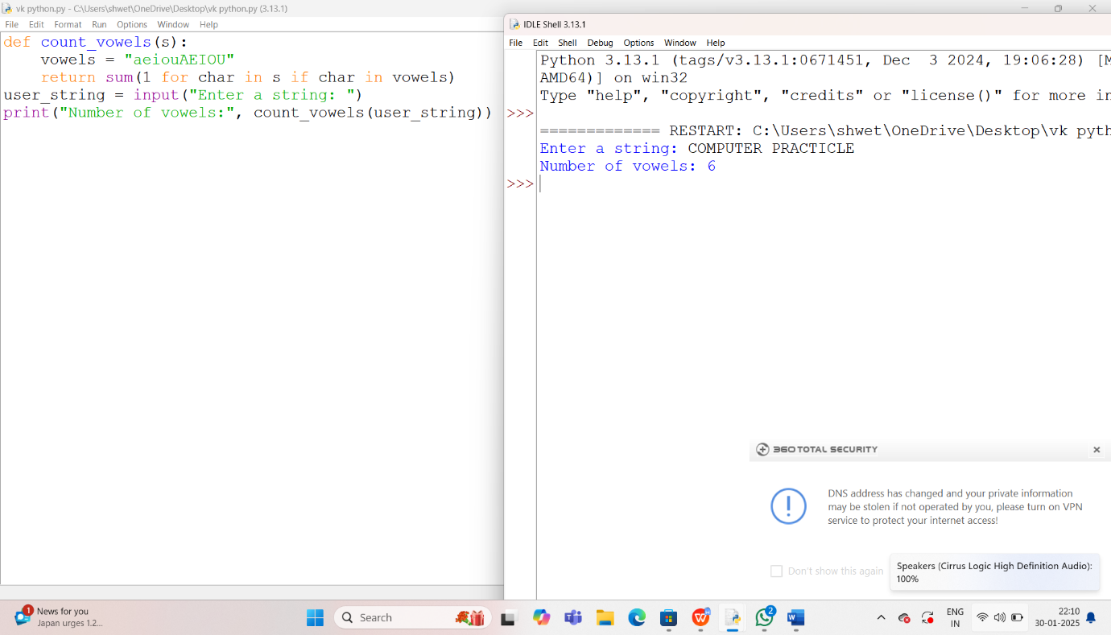

2) Write your own functions (without using built-in functions) to convert all characters of a string into lower

case/upper case/toggle case.

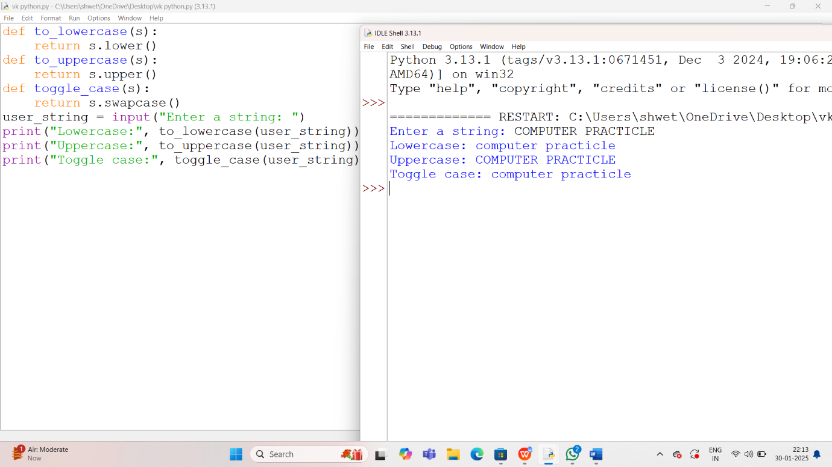

1. Accept two strings. Check whether one string is there in another string.

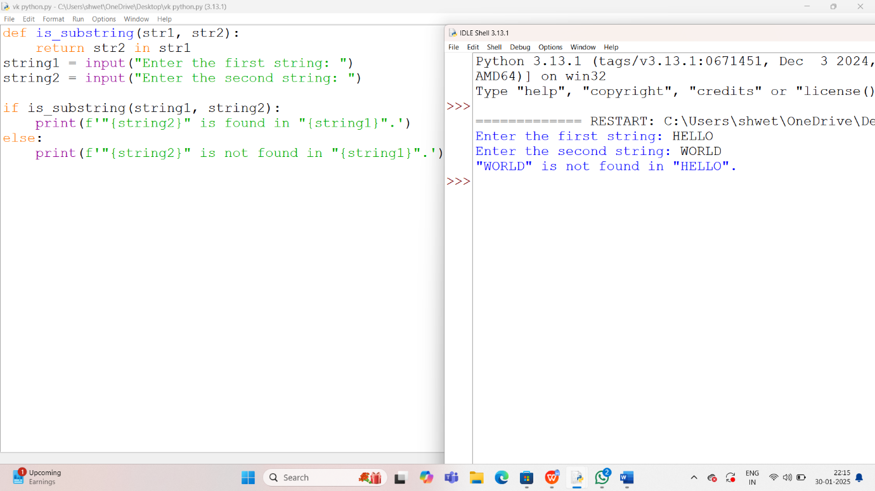

4)Write a function that removes one string from another string, if prevent.

